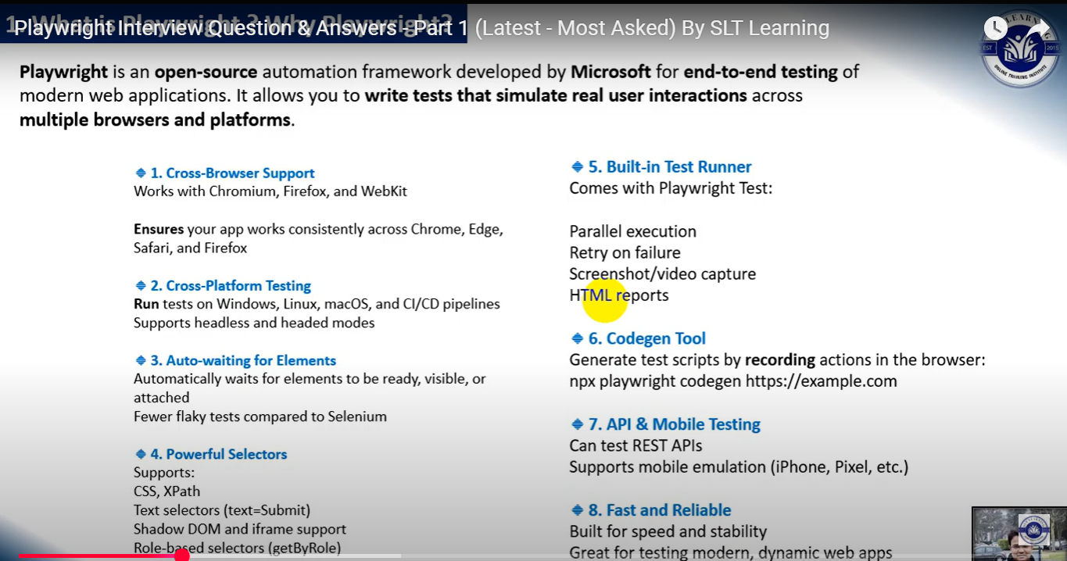

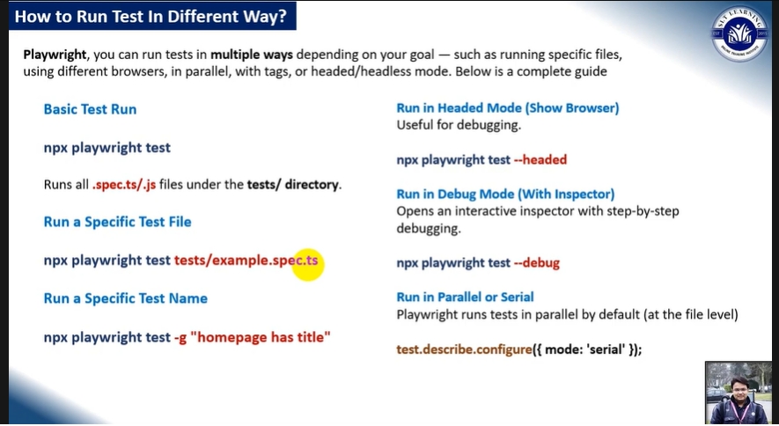

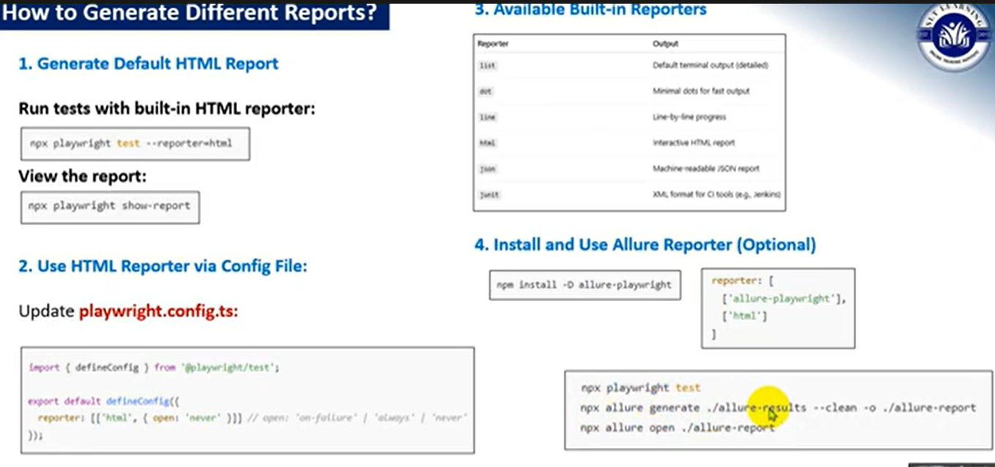

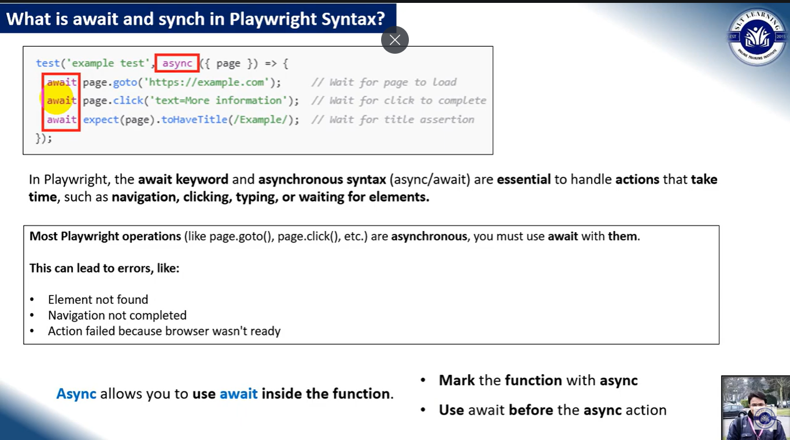

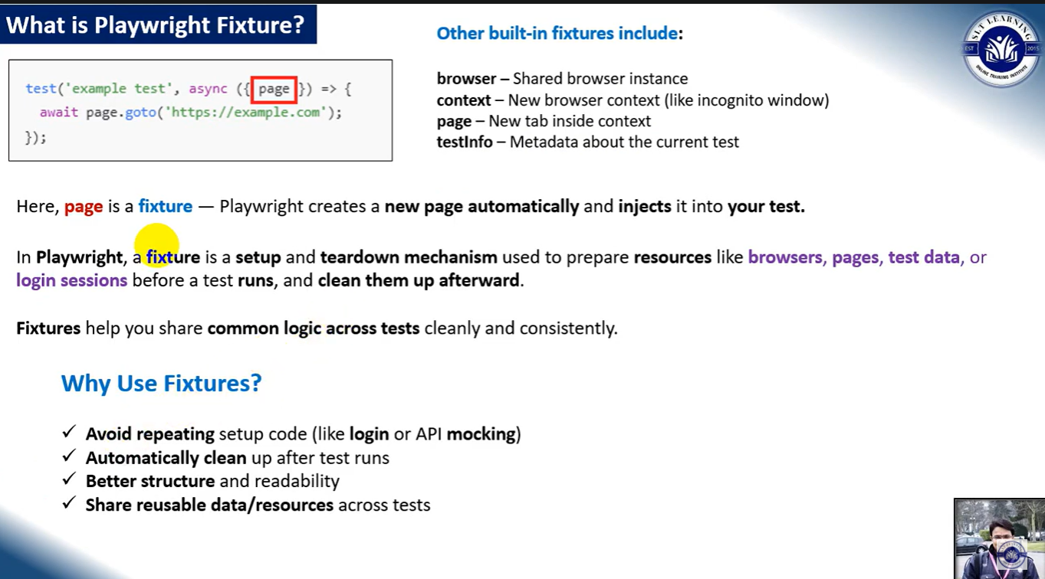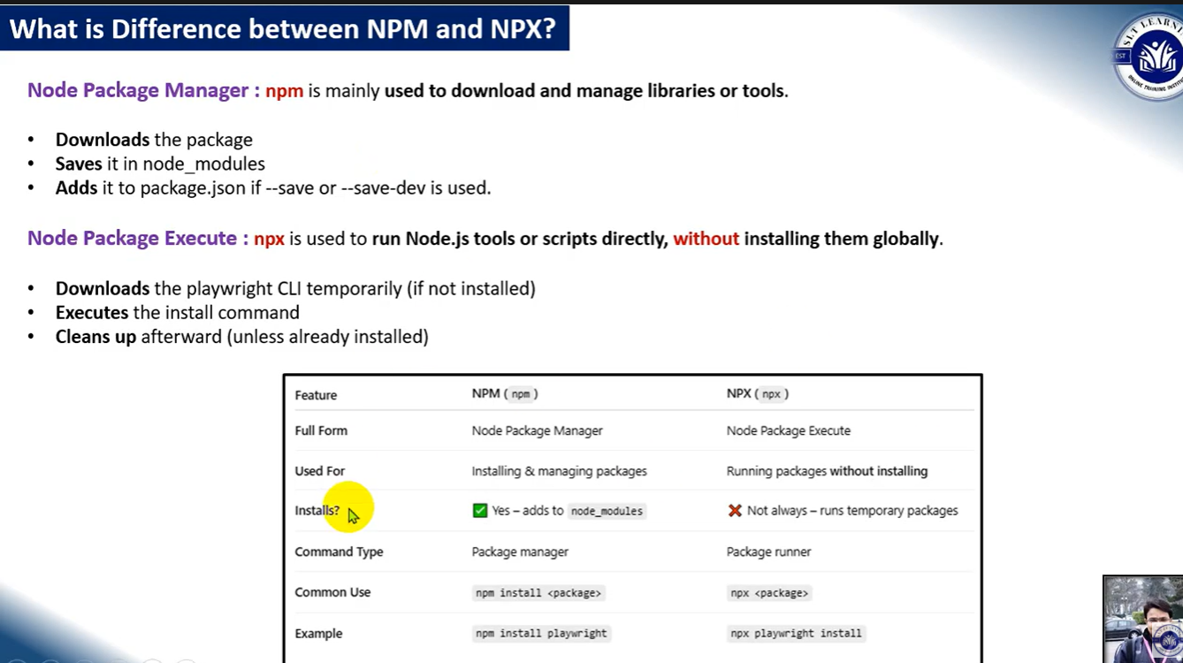

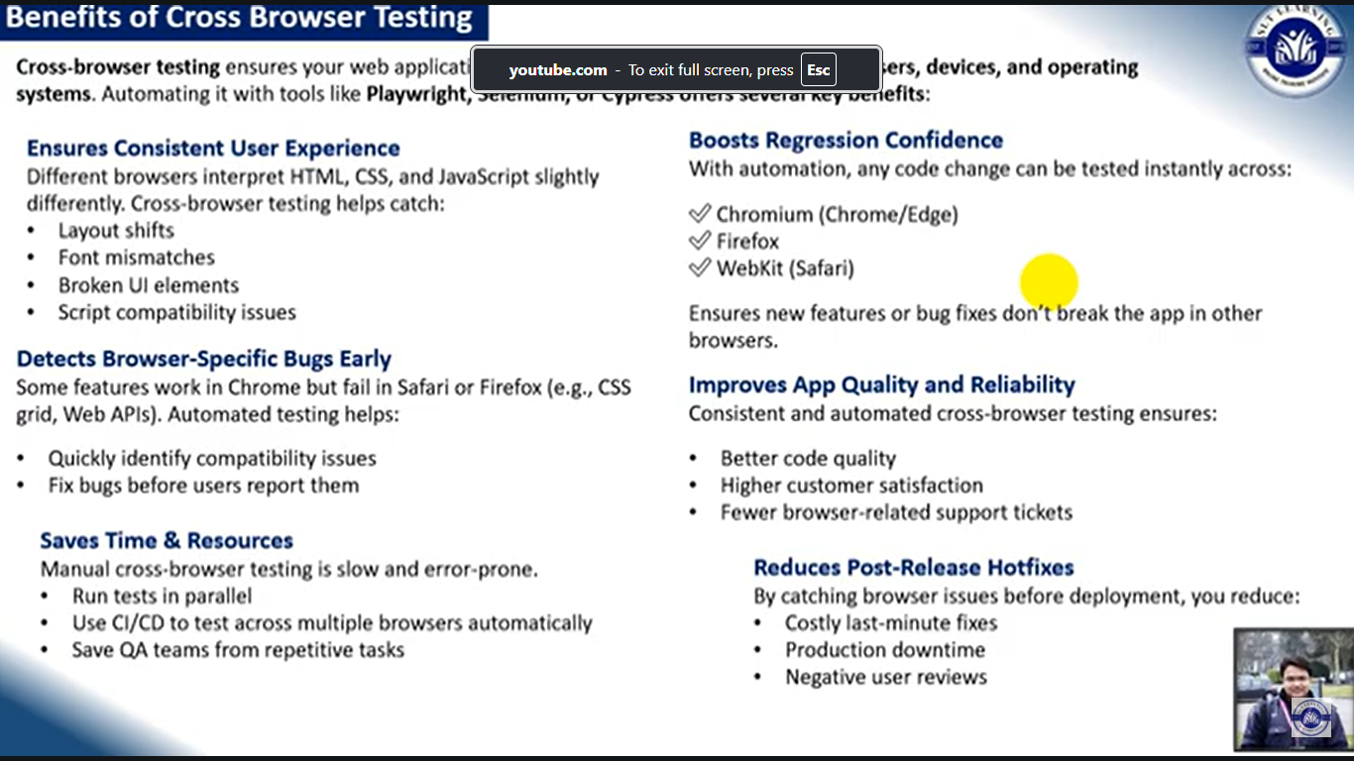

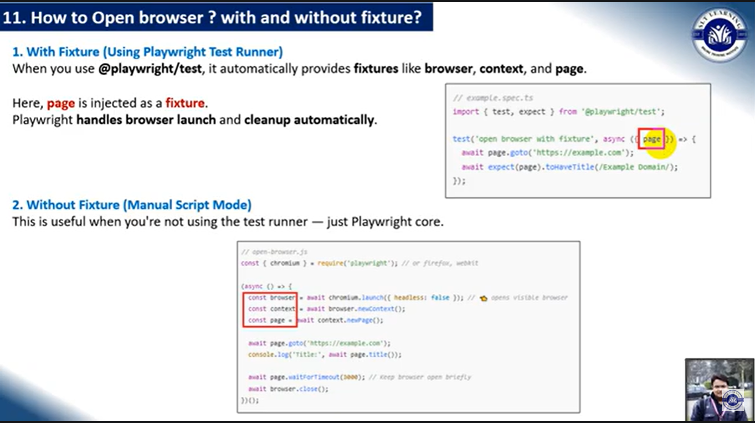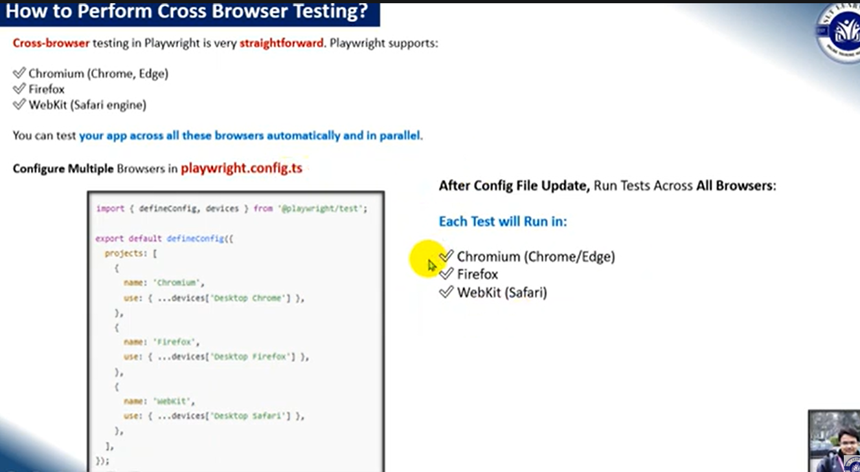

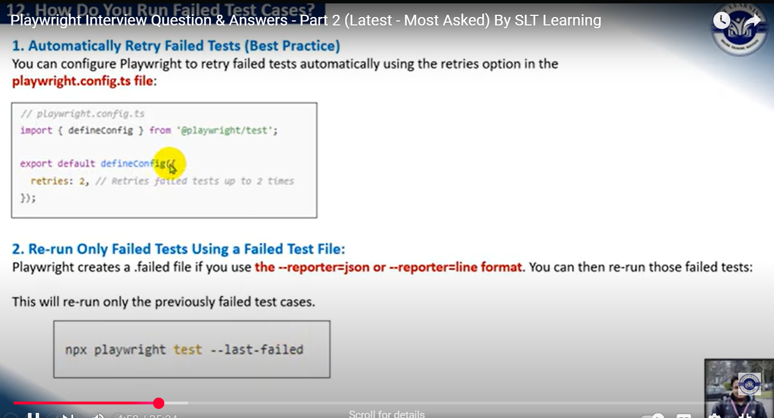

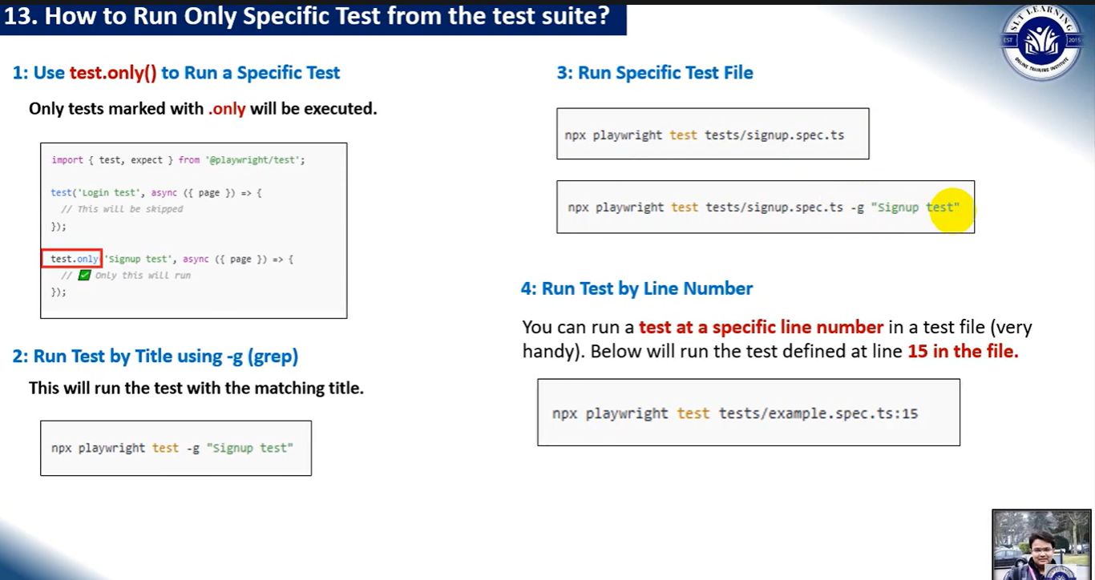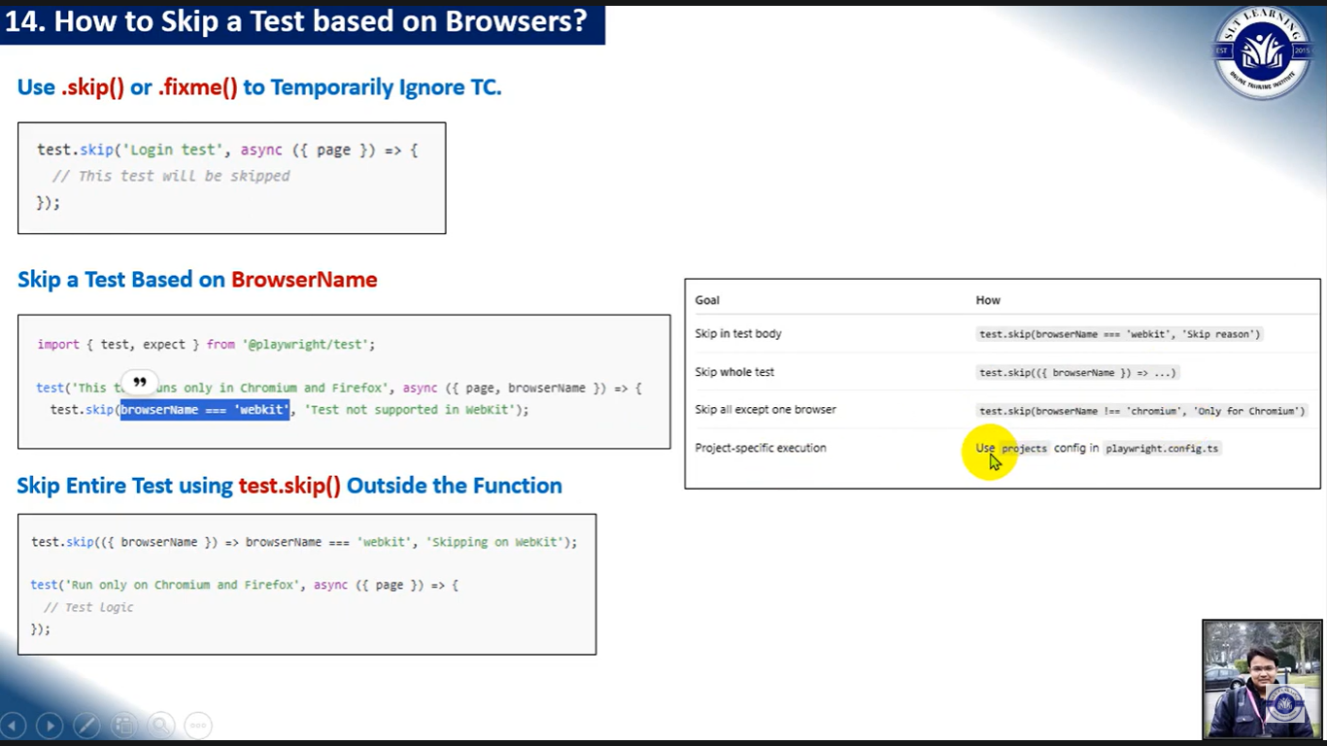

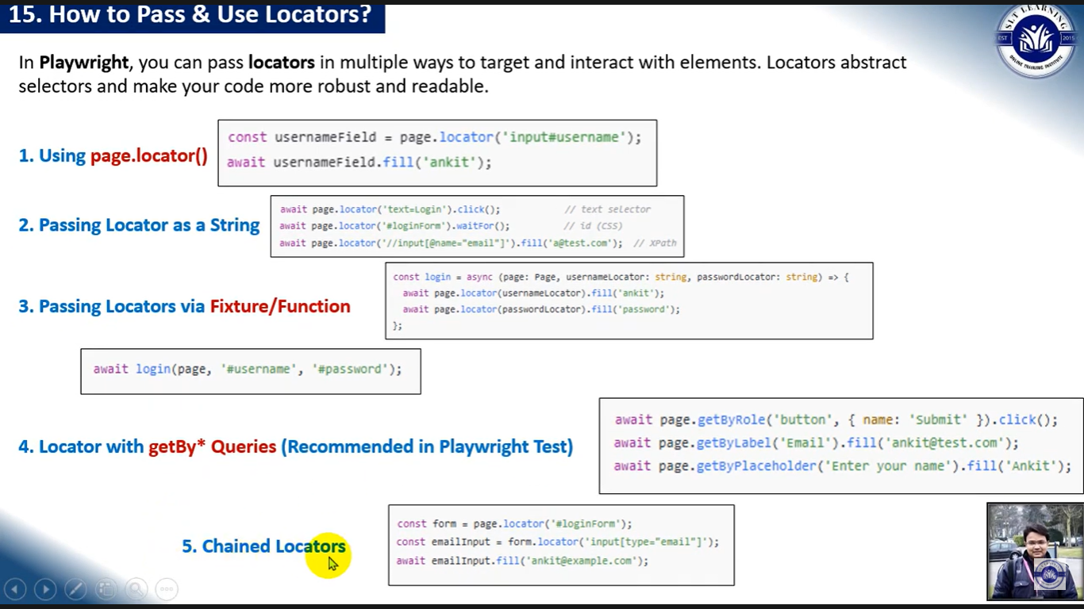

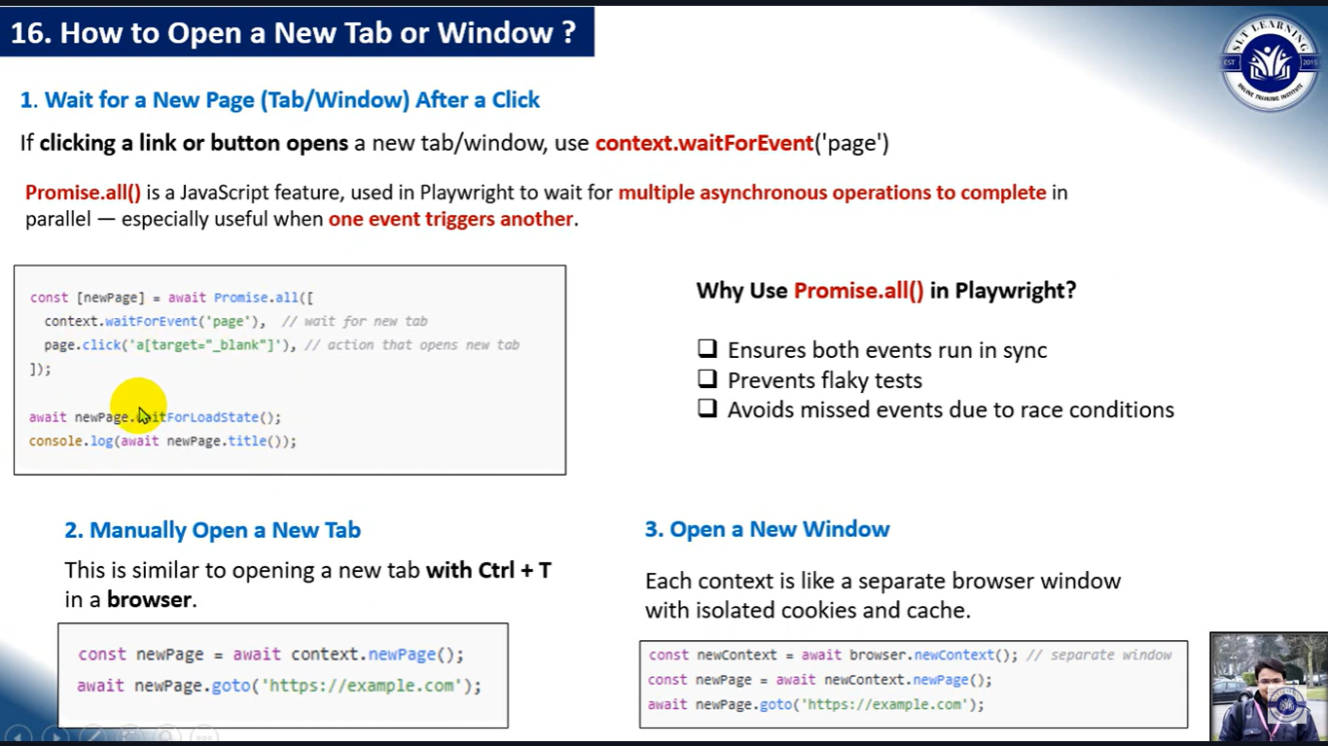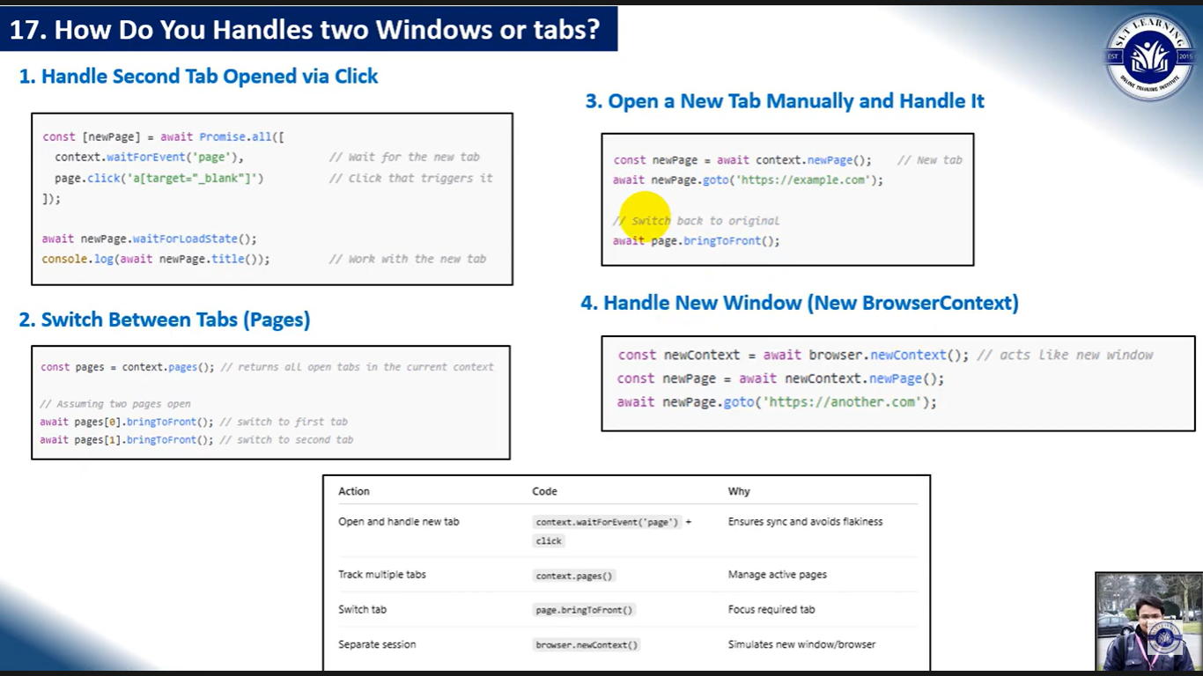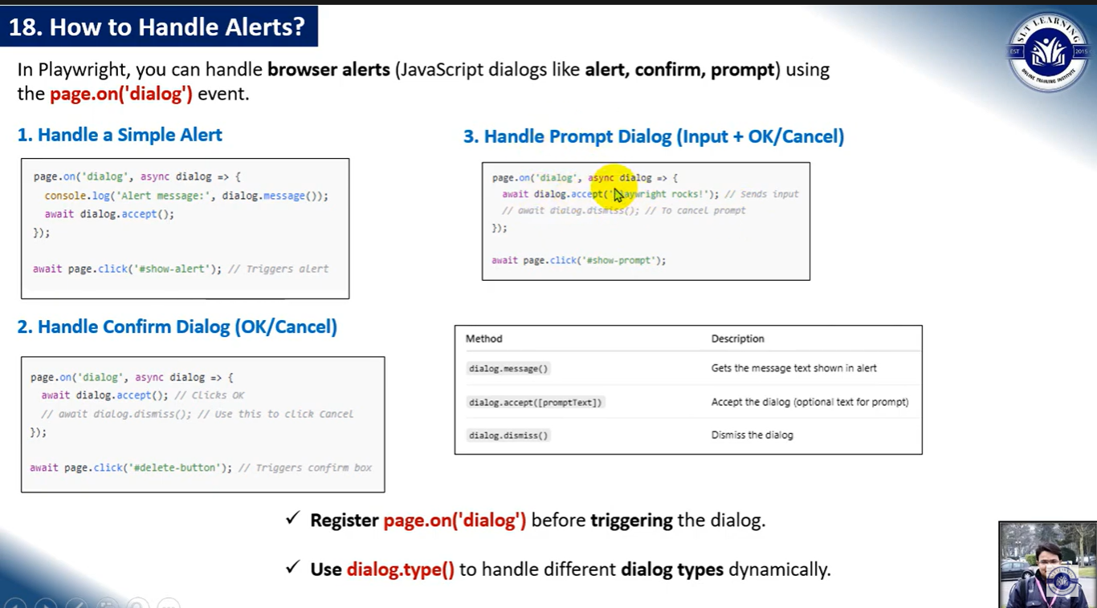

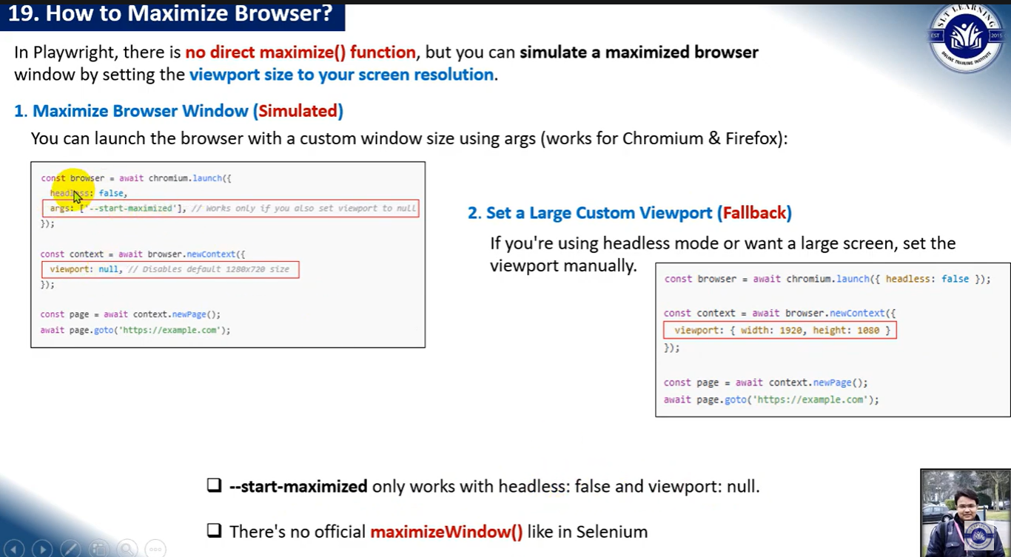

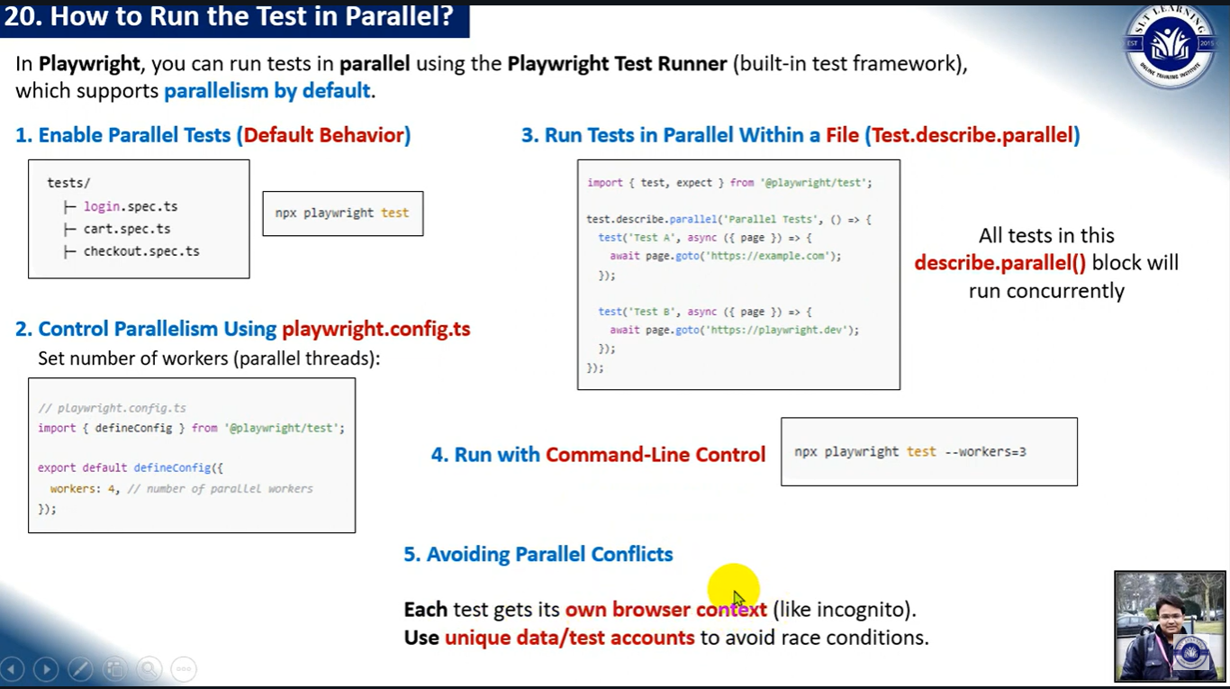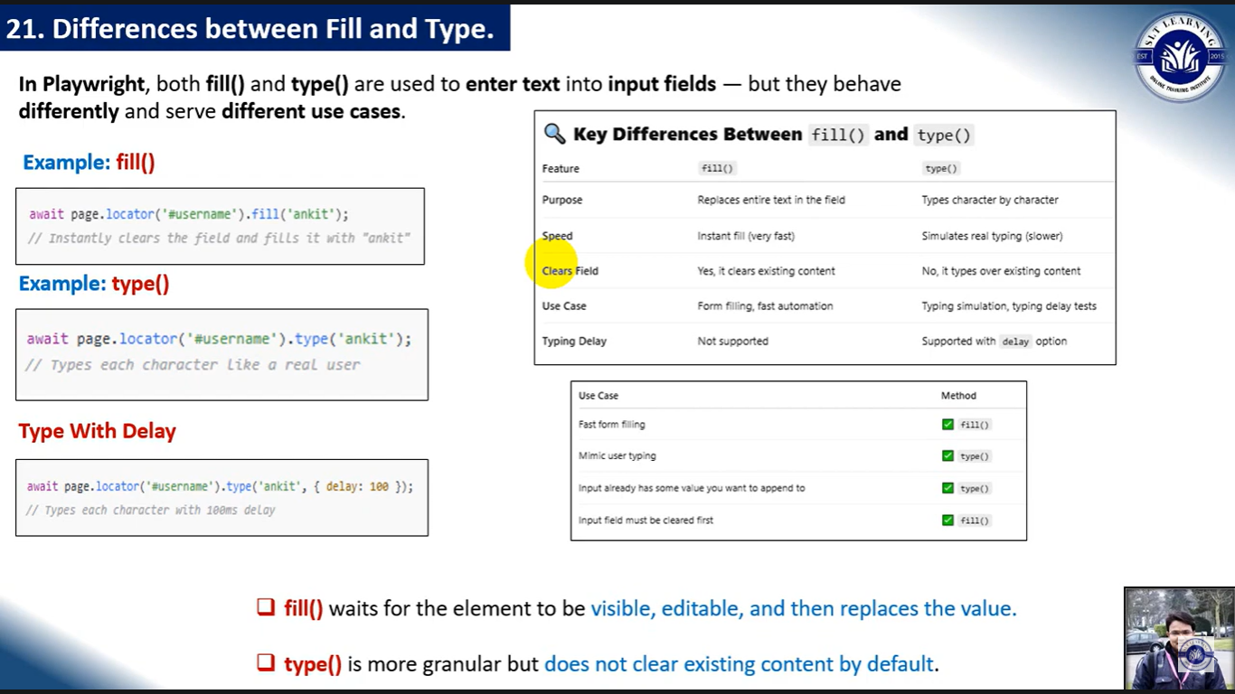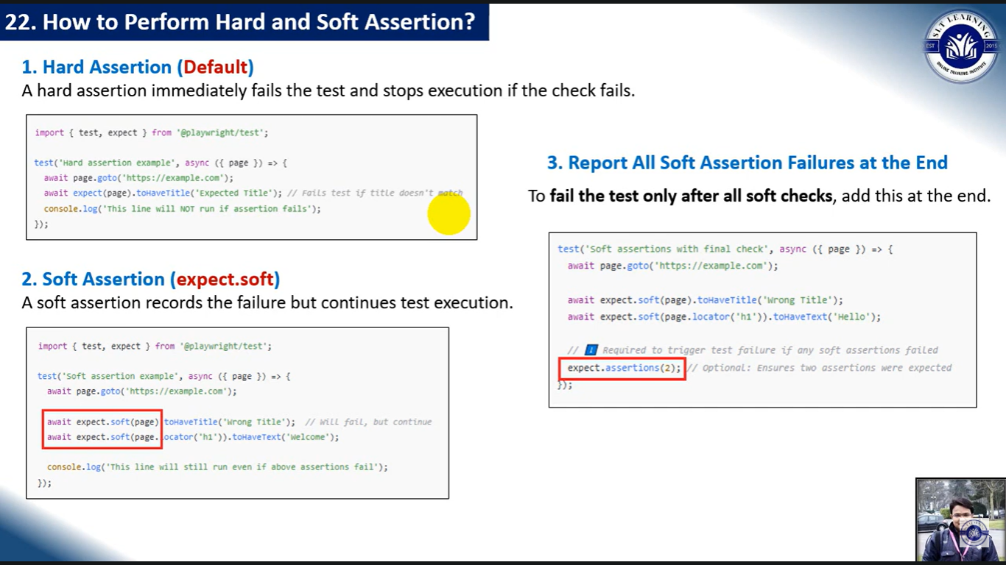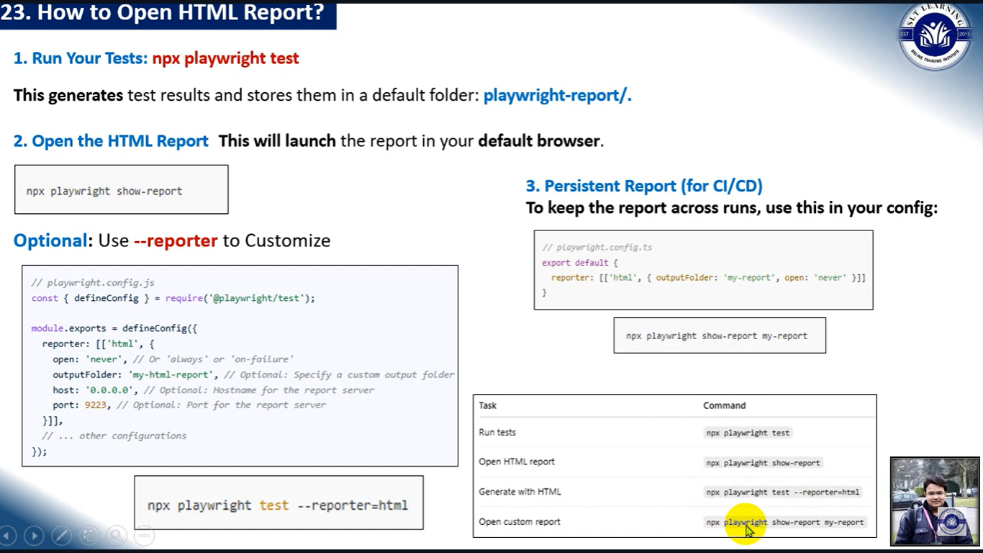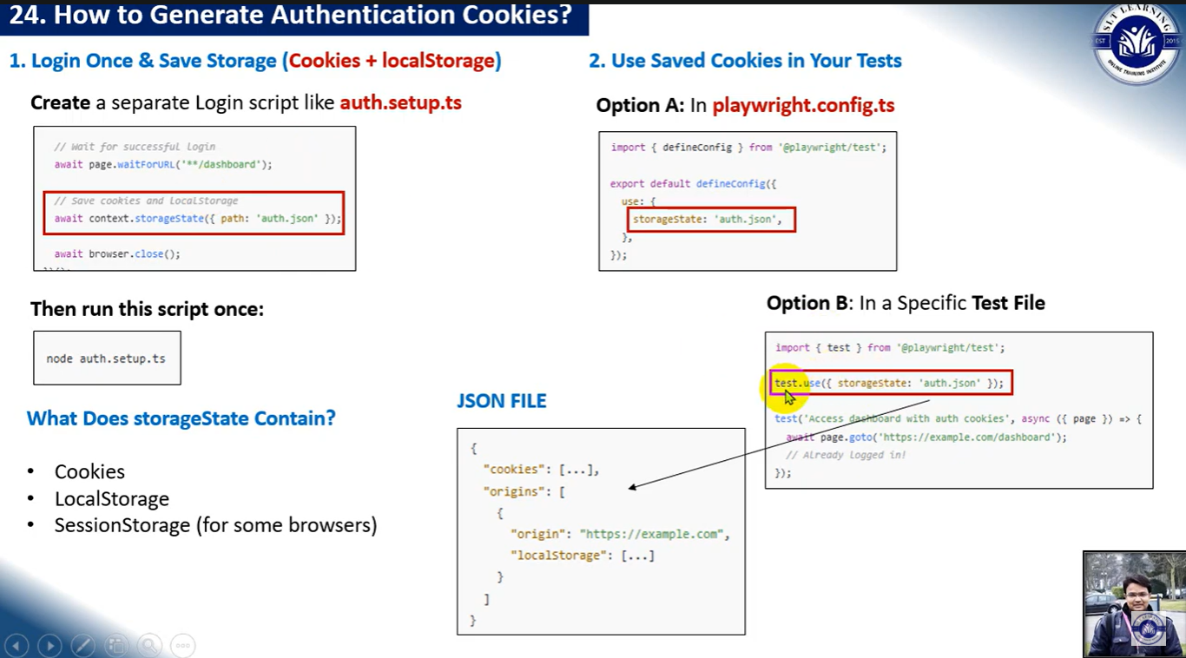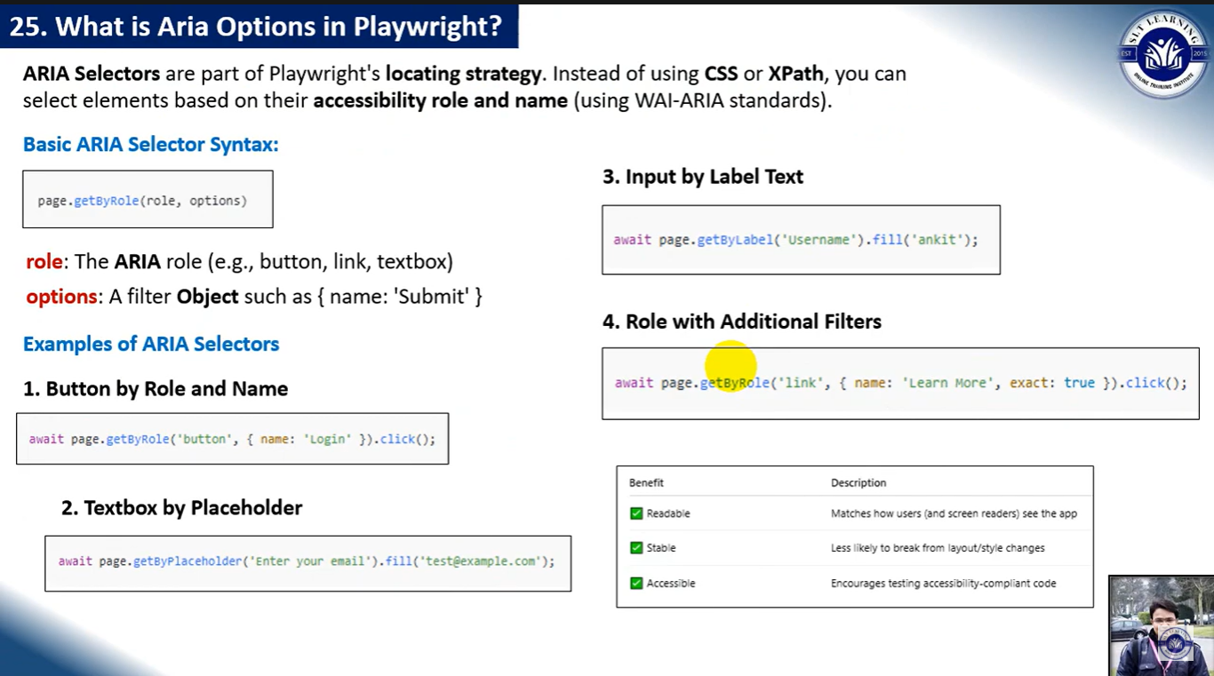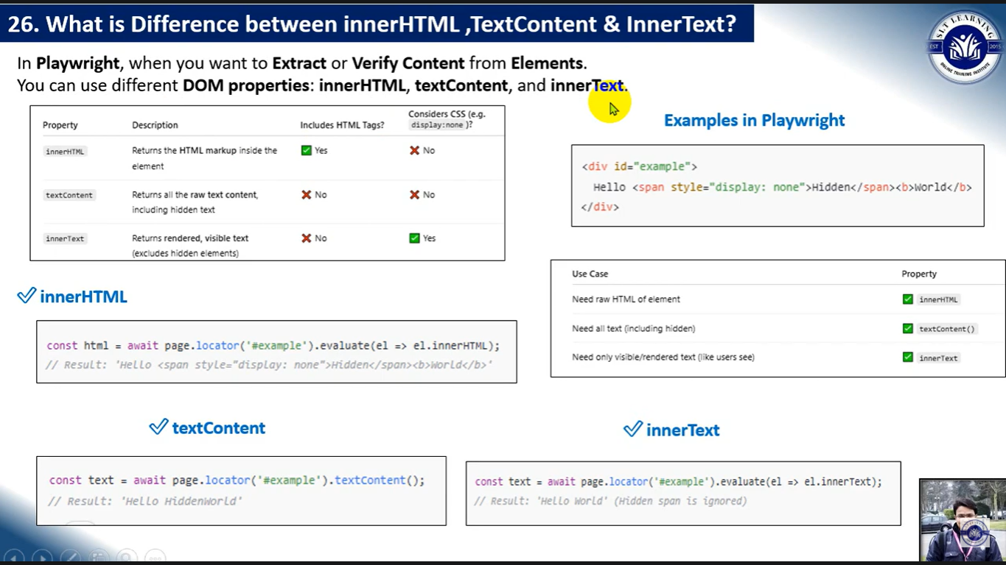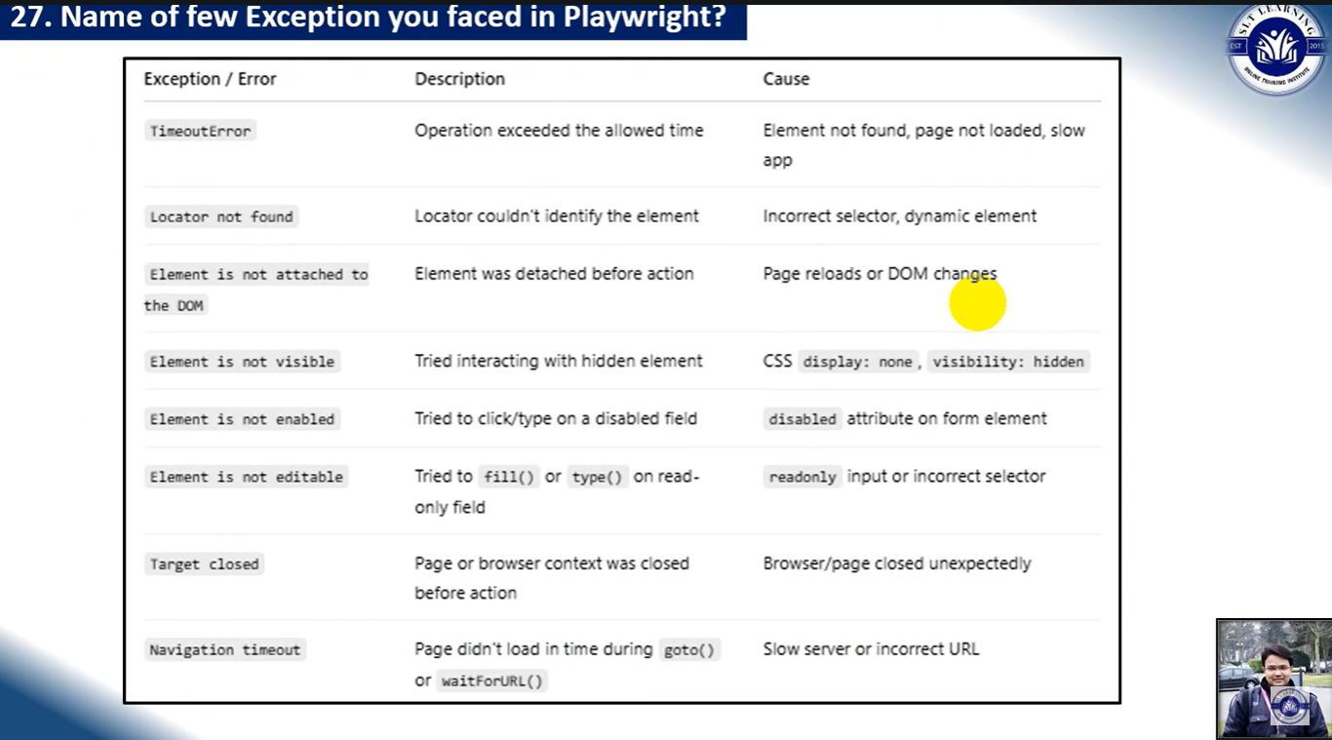

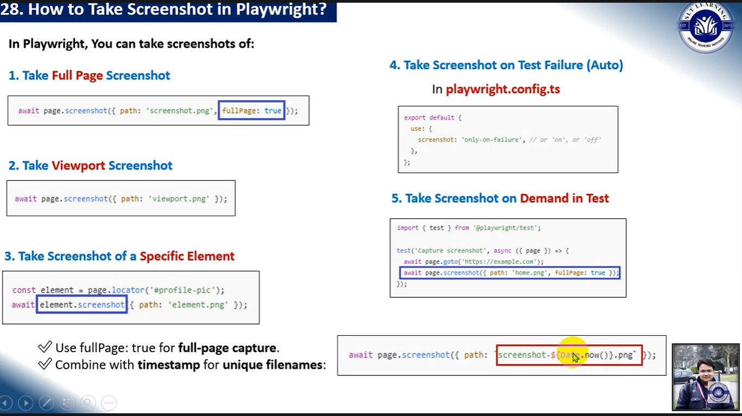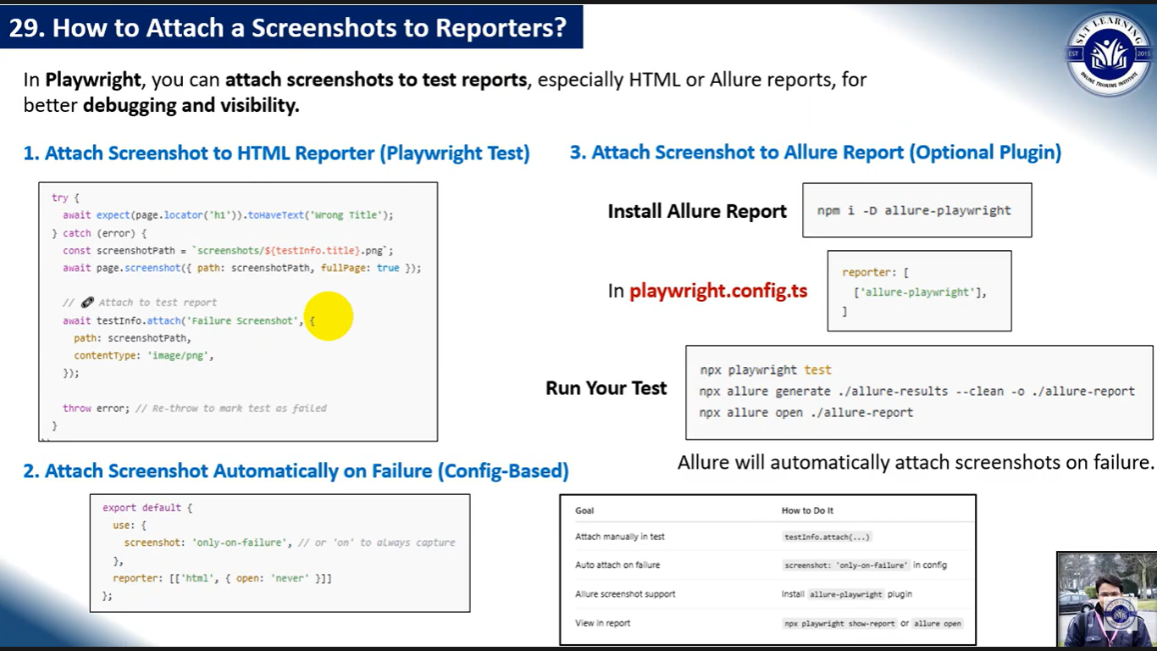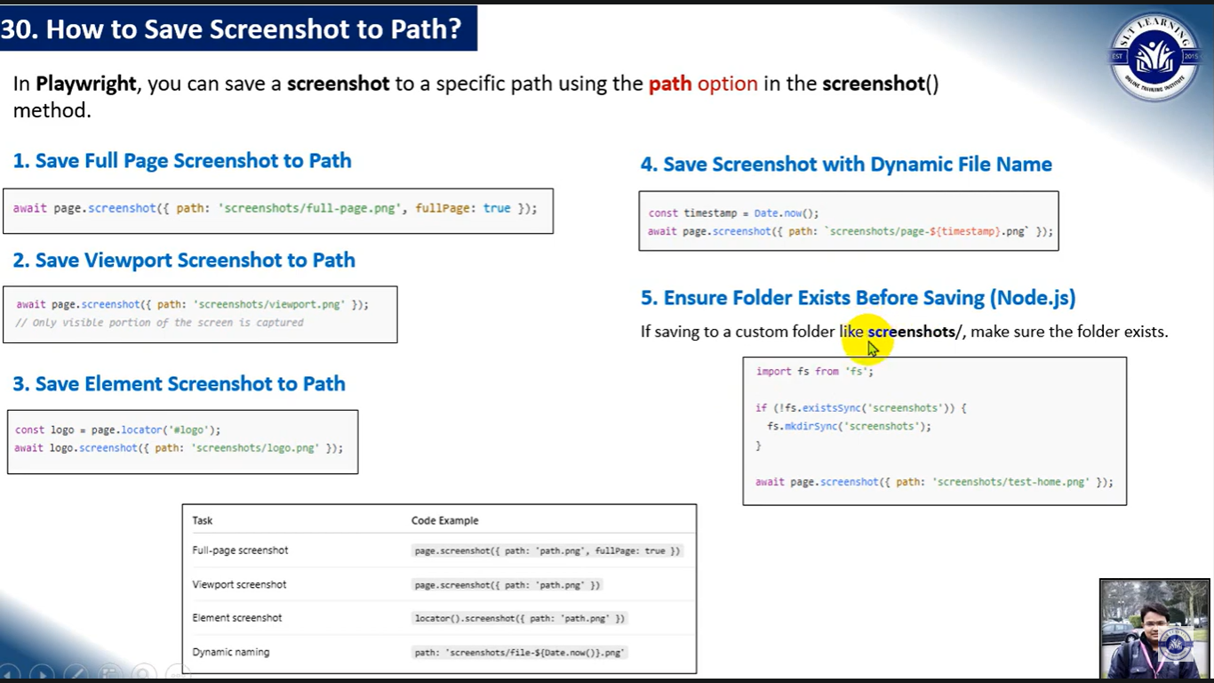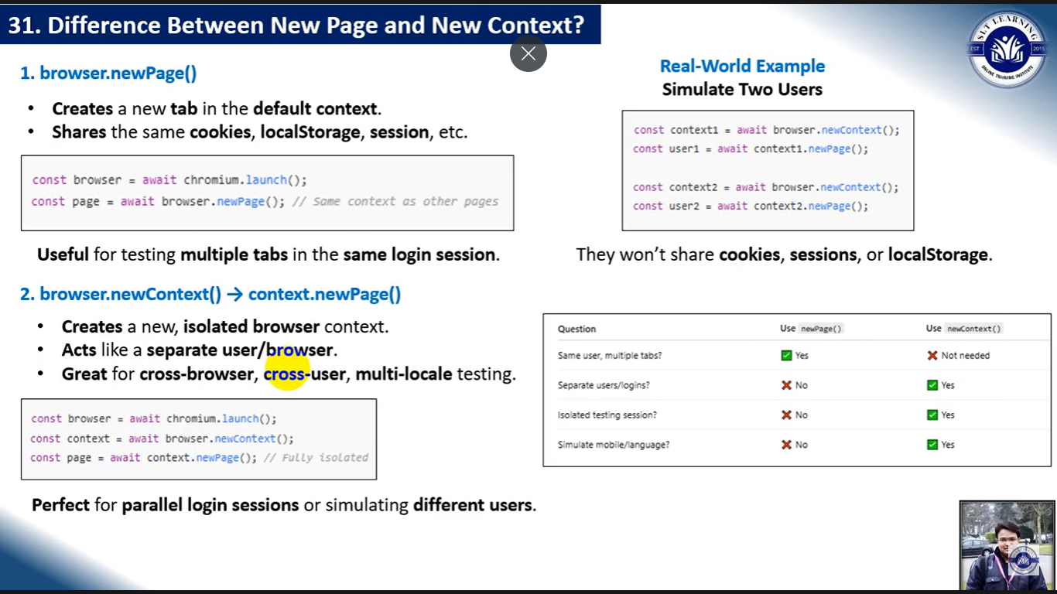

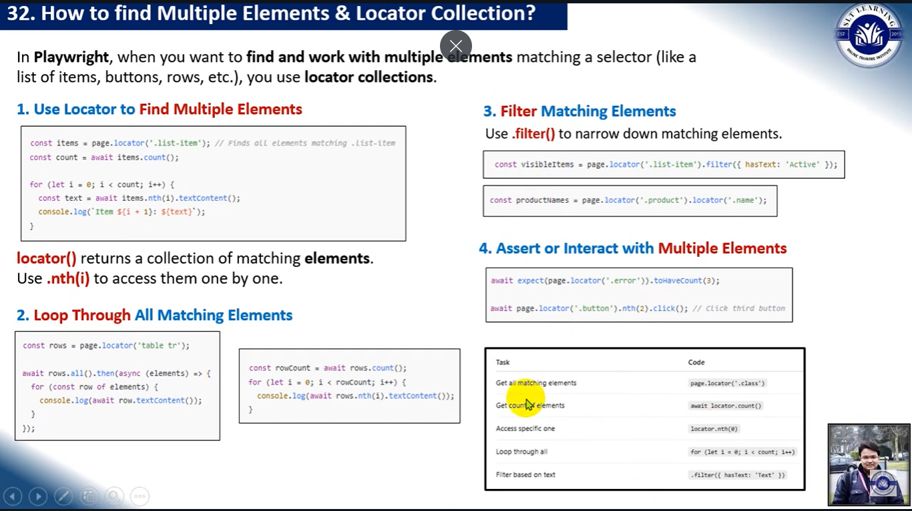

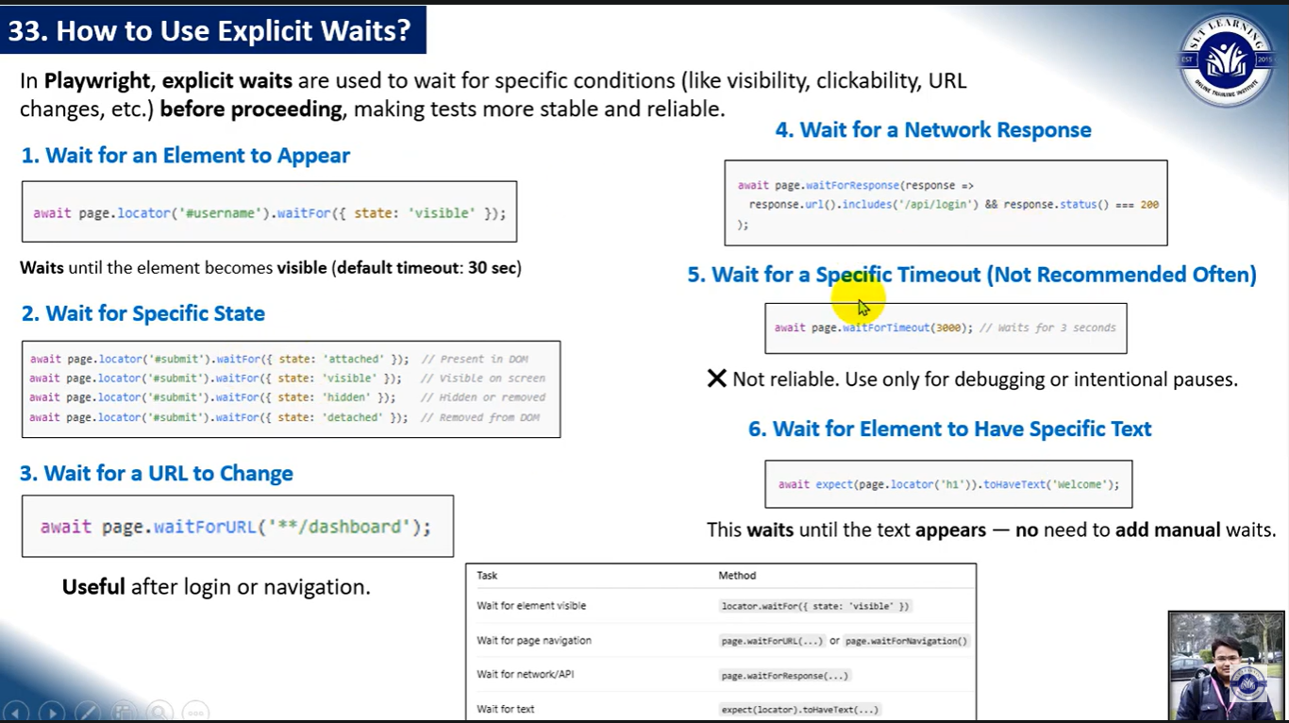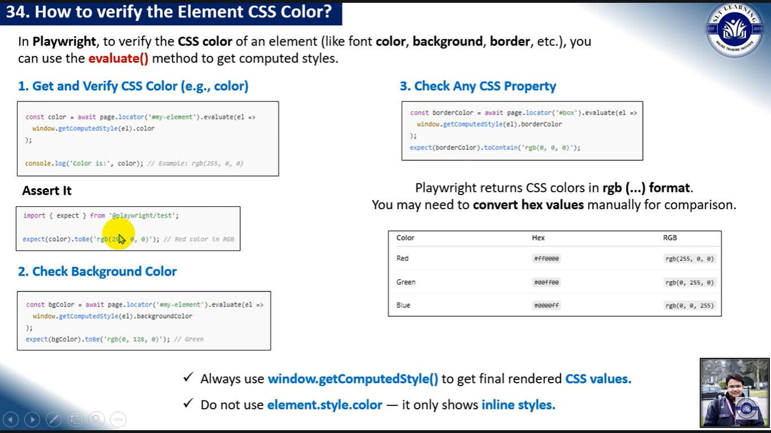

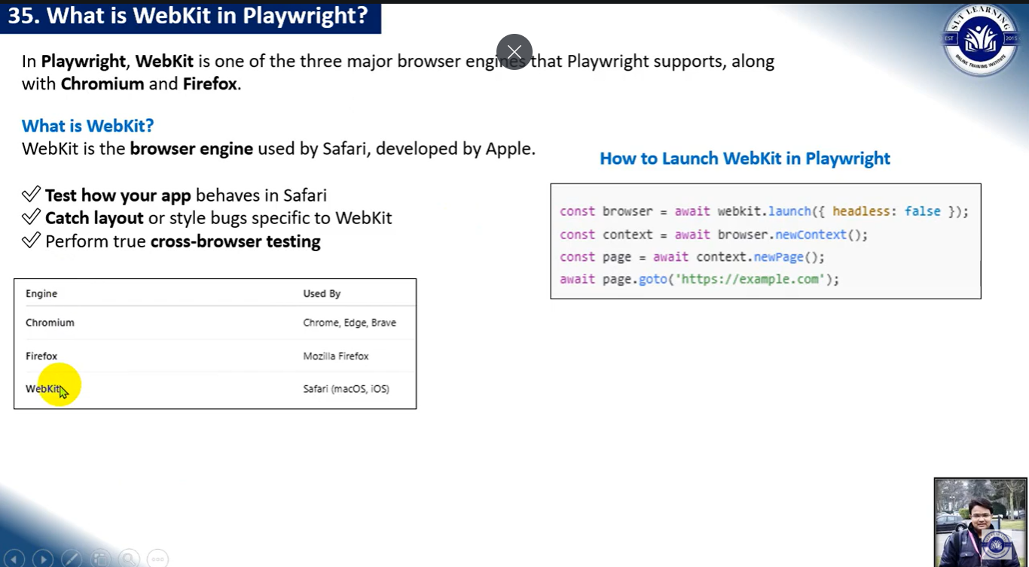.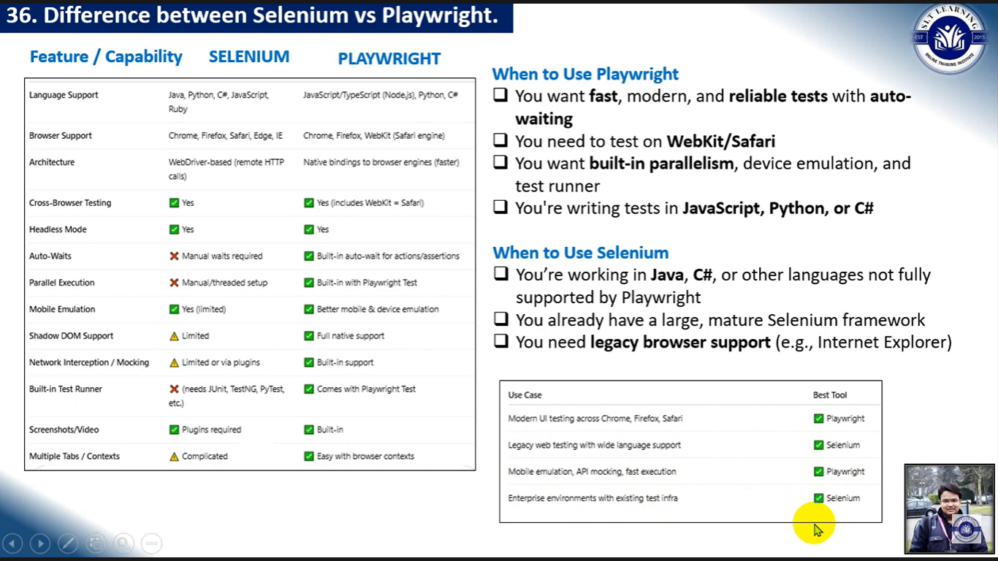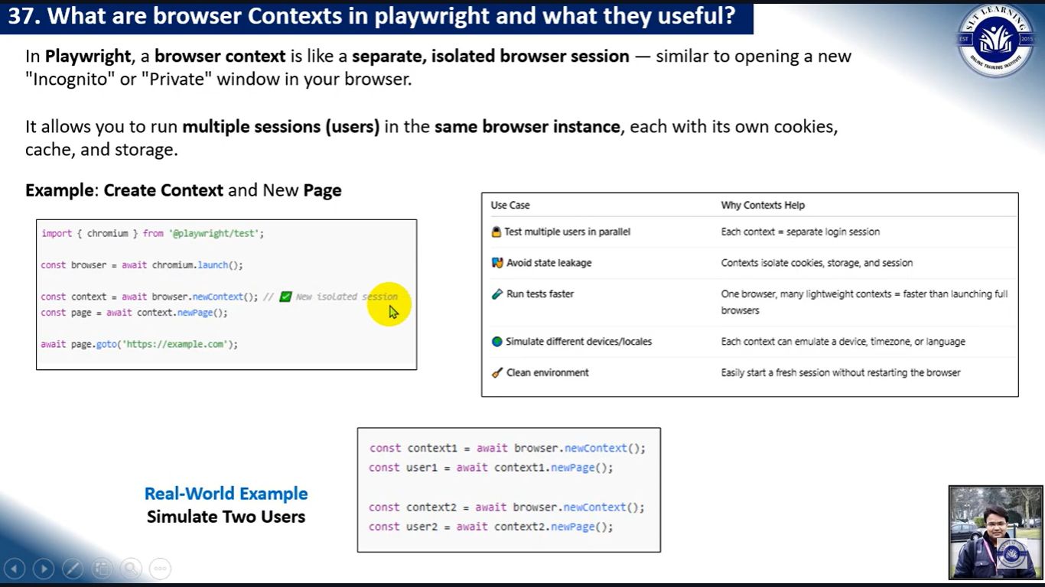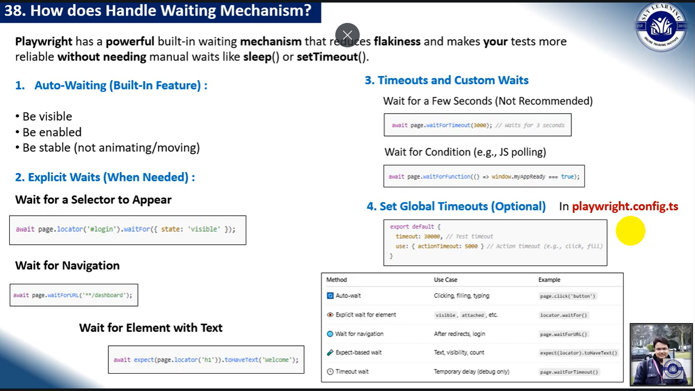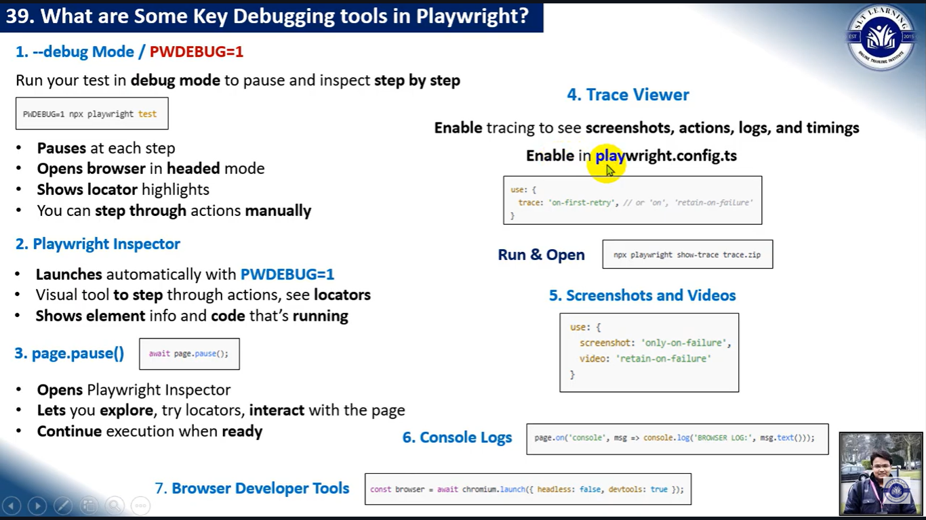

Playwright Installation:

npm init playwright@latest

1. Run the Test

npx playwright test

1. HTML Test Reports.

npx playwright show-report

1. Run the Test in UI Mode

npx playwright test --ui

1. Run tests in headed mode

npx playwright test --headed

1. Run Test on different browser

npx playwright test --project = “Chromium”

1. Run the specific test

npx playwright test demo.spec.js

1. Run last failed test

npx playwright test --last -failed

1. Debug the test

npx playwright test --debug

1. Trace the run details

npx playwright test --trace on

Config file : trace : ‘on’ off/on-failure/ on-first-retry

1. Run failed testcases

npx playwright test --retries =2

1. How to run test parallel?

npx playwright test --workers = 3

1. Navigation

page.goto(“url”)

1. Recording a test

npx playwright codegen demo.playwright.dev/todomvc

**Action** **Description**

locator.check() Check the input checkbox

locator.click() Click the element

locator.uncheck() Uncheck the input checkbox

locator.hover() Hover mouse over the element

locator.fill() Fill the form field, input text

locator.focus() Focus the element

locator.press() Press single key

locator.setInputFiles() Pick files to upload

locator.selectOption() Select option in the drop down

**Assertion** **Description**

expect(locator).toBeChecked() Checkbox is checked

expect(locator).toBeEnabled() Control is enabled

expect(locator).toBeVisible() Element is visible

expect(locator).toContainText() Element contains text

expect(locator).toHaveAttribute() Element has attribute

expect(locator).toHaveCount() List of elements has given length

expect(locator).toHaveText() Element matches text

expect(locator).toHaveValue() Input element has value

expect(page).toHaveTitle() Page has title

expect(page).toHaveURL() Page has URL

Why Playwright?  
it is fast

It has his own testrunner and built in reports

It has cross browser testing

It supports multiple languages

It has huge variety of locator finding startegies

It supports both web and api

It has feature like codegen and traces

It has vedio generation of tests and

In built wait mechanism

What is the diff between npm and npx?

NPM: (Node Package manager)It is a package manager usted to delete, install and update javascript packages on your machine

NPX :(NodePackageExecutor) It is a package executor, and it is used to execute javascript pakages directly, without installing them.

What is the diff between newPage and newContext?  
newPage will carry forward all the cookies and sessions from the already opened browser

Whereas the new context will have a new session.

What is a playwright fixture?

In Playwright, a fixture is a reusable setup or helper that provides a specific context or resource for your tests.

Fixture Description

browser An instance of Chromium, Firefox, or WebKit

context A browser context (isolated session like incognito)

page A new tab in the browser context

Ex:

Import{test} from “.@playwright/test”;

Test(“title of the test with page fixtures”, async ({page})=>{

})

Here page is the fixture where you don’t want to open browser or close No need to repeat login/setup logic in every test.

How to open browsers?

Import{test} from “@playwright/test”;

Test(“title of the test without page fixtures”, async ()=>{

Const browser = await chromium.launch();

Const context = await browser.newContext();

Const page = await context.newPage();

Await page.goto([www.google.com](http://www.google.com));

})

((or))

Import{test} from “@playwright/test”;

Test(“title of the test with page fixtures”, async ({page})=>{

Await page.goto([www.google.com](http://www.google.com));

})

How do you handle windows?

// Wait for the new page (popup window) to open

const [newPage] = await Promise.all([

context.waitForEvent('page'), // Wait for new page

page.click('a[target="_blank"]'), // Trigger the new window (example selector)

]);

// Wait for the new page to load

await newPage.waitForLoadState();

How to open new tab?

// Wait for the new tab to open

const [newTab] = await Promise.all([

context.waitForEvent('page'),

page.click('a[target="_blank"]'), // or window.open link

]);

(((or)))

import { test, expect } from '@playwright/test';

test('Open a new tab manually', async ({ context }) => {

// First tab

**const page1 = await context.newPage();**

await page1.goto('https://example.com');

await expect(page1).toHaveTitle(/Example Domain/);

// Open new tab

**const page2 = await context.newPage();**

await page2.goto('https://playwright.dev');

await expect(page2).toHaveTitle(/Playwright/);

// You can interact with both tabs

**await page1.bringToFront();** // Switch focus back to first tab

});

How do you perform cross browser testing?

We have to configure browsers in playwright.config.js file

Projects: [

{

Name: ‘chromium’,

Use : {browserName: “chromium”}

},

{

Name: ‘webkit’,

Use : {browserName: “WebKit’}

},

{

Name: ‘Firefox,

Use : {browserName: “firefox}

},

]

How to run only specific tests from a test suite?

Using test.only()

test.describe(‘group of tests”, ()=>{

test.only(‘test1’,async({page})=>{

});

test(‘test2’,async({page})=>{

});

test(‘test3’,async({page})=>{

});

})

How to handle alerts?

Page.on(“dialog”,dialog=>dialog.accept())

Page.on(“dialog”, dialog=>dialog.dismiss());

Page.on(“dialog”, dialog=>dialog.accept(“Input the alert box”);

Page.on(“dialog”, async dialog=>{

Console.log(Dialog.message())

})

Name few exceptions you faced in playwright?

1.Mostly it is a timeout Exception

await page.click('#submit-button'); // throws if button not found in time

2.Error: strict mode violation: selector matched multiple elements

You're using a strict selector (like getByRole, locator) and it matches more than one element.

3. Error: Page closed or Error: Execution context was destroyed

ou're trying to access a page or frame that has been closed or navigated away.

4. ElementHandleError: Element is not attached to the DOM

You're trying to interact with an element that was removed or re-rendered.

How to do hard and soft assertion?

If use hard assertion step is failed the it stops the execution but use soft it fails that particular step and continue the execution

await expect(page).tohaveURL(“www.gmail.com”); //hard

await expect.soft(page).tohaveURL((“www.gmail.com”); //soft

Diff between Fill and Type?

Fill: will clear the existing values and passess the input string

Type: will pass the data one by one character(it will not clear existing value it appends the data)

How to attach the screenshot to the reporter?

const screenshot = await page.screenshot({ path: ‘screenshot.png’ });

import { test, expect } from '@playwright/test';

test('Attach screenshot manually', async ({ page }, testInfo) =>

{

await page.goto('https://example.com');

// Take screenshot

const screenshotPath = await page.screenshot({ path: `screenshots/example.png` });

// Attach it to report

await testInfo.attach('screenshot', {

path: screenshotPath,

contentType: 'image/png',

});

});

How to find multiple locators?

Const Images = page.locator(“img”)

Const multipleImages = images.all();

For(const img of multipleImages)

{

}

Annotations:

test.skip() marks the test as irrelevant

test.fail() marks the test as failing

test.slow() marks the test as slow and triples the test timeout

ex;

test.only('focus this test', async ({ page }) => {  
 *// Run only focused tests in the entire project.*  
});

test.skip('skip this test', async ({ page }) => {  
 *// This test is not run*  
});

You can skip certain test based on the condition.

test('skip this test', async ({ page, browserName }) => {  
 test.skip(browserName === 'firefox', 'Still working on it');  
});

## Group tests[​](https://playwright.dev/docs/test-annotations#group-tests)

You can group tests to give them a logical name or to scope before/after hooks to the group.

import { test, expect } from '@playwright/test';  
  
test.describe('two tests', () => {  
 test('one', async ({ page }) => {  
 *// ...*  
 });  
  
 test('two', async ({ page }) => {  
 *// ...*  
 });  
});

**Tag tests**

import { test, expect } from '@playwright/test';  
  
test('test login page', {  
 tag: '@fast',  
}, async ({ page }) => {  
 *// ...*  
});  
  
test('test full report @slow', async ({ page }) => {  
 *// ...*  
});

npx playwright test --grep "@fast|@slow"

## Parallelize tests in a single file

## By default, tests in a single file are run in order. If you have many independent tests in a single file, you might want to run them in parallel with test.describe.configure().

test.describe.configure({ mode: 'parallel' });  
  
test('runs in parallel 1', async ({ page }) => { */* ... */* });  
test('runs in parallel 2', async ({ page }) => { */* ... */* });

## Serial mode[​](https://playwright.dev/docs/test-parallel#serial-mode)

You can annotate inter-dependent tests as serial. If one of the serial tests fails, all subsequent tests are skipped. All tests in a group are retried together.

import { test, type Page } from '@playwright/test';  
  
*// Annotate entire file as serial.*  
test.describe.configure({ mode: 'serial' });  
  
let page: Page;  
  
test.beforeAll(async ({ browser }) => {  
 page = await browser.newPage();  
});  
  
test.afterAll(async () => {  
 await page.close();  
});  
  
test('runs first', async () => {  
 await page.goto('https://playwright.dev/');  
});  
  
test('runs second', async () => {  
 await page.getByText('Get Started').click();  
});

## Opt out of fully parallel mode[​](https://playwright.dev/docs/test-parallel#opt-out-of-fully-parallel-mode)

If your configuration applies parallel mode to all tests using [testConfig.fullyParallel](https://playwright.dev/docs/api/class-testconfig" \l "test-config-fully-parallel), you might still want to run some tests with default settings. You can override the mode per describe:

test.describe('runs in parallel with other describes', () => {  
 test.describe.configure({ mode: 'default' });  
 test('in order 1', async ({ page }) => {});  
 test('in order 2', async ({ page }) => {});  
});

# Retries

Test retries are a way to automatically re-run a test when it fails. This is useful when a test is flaky and fails intermittently

playwright.config.ts

import { defineConfig } from '@playwright/test';  
  
export default defineConfig({  
 *// Give failing tests 3 retry attempts*  
 retries: 3,  
});

# UI Mode

UI Mode lets you explore, run, and debug tests with a time travel experience complete with a watch mode. All test files are displayed in the testing sidebar, allowing you to expand each file and describe block to individually run, view, watch, and debug each test.

npx playwright test –ui

Q: How do you handle flaky tests in Playwright?

🟢 Improved Answer:

In Playwright, flaky tests usually happen because of timing issues, dynamic content, or unstable locators. To handle them, I use tracing and video recording to debug the root cause. I rely on Playwright’s auto-wait feature, which waits for elements to be ready. When needed, I use extra waits like waitForSelector or waitForLoadState to make sure the page is fully loaded or use assertion-based waits like expect(locator).toBeVisible() to wait for the element to be ready before interacting and I also configure retries in the Playwright config to automatically re-run failed tests

Q: How did you use BDD and POM together in your project?

🟢 Improved Answer:

I used Page Object Model (POM) to separate the locators and reusable methods for each page into classes, making the test code modular and maintainable.

Then, I implemented BDD using Cucumber with Gherkin syntax to write` clear, business-readable test scenarios. In the step definition files, I connected those scenarios to the automation logic by calling the appropriate page object methods.

This combination helped in improving both test readability and maintainability.

Q: What’s the difference between implicit and explicit waits?

🟢 Improved Answer:

Playwright doesn’t use traditional implicit waits like Selenium. Instead, it has a built-in auto-waiting mechanism, which waits for elements to become actionable (clickable, visible, etc.) before interacting.

In addition, we can use explicit waits like:

waitForSelector

waitForResponse

waitForURL

waitForLoadState

And even waitForTimeout for hard waits (though it’s not recommended for regular use).

These are helpful when we need more control over wait behavior in dynamic applications.

**Q: How did you integrate Jenkins with your Playwright test suite?**

🟢 Improved Answer:

I created a Jenkins job to run the Playwright automation suite.

In the job configuration:

I provided the Git repository path or the local path to the project.

In the build step, Used a batch command like npx playwright test to trigger test execution.

I also generate HTML test reports and archive them as artifacts.

For automation, I configure Git polling and scheduled triggers so the tests run automatically on code changes or at specific times."

Q: What AI tools have you used in your QA workflow?

🟢 Improved Answer:

In my last project, I used TechBud.AI—an AI-powered tool provided by my company—for generating test cases based on user stories and requirements.

I also used ChatGPT regularly for solving automation-related issues, debugging JavaScript code in Playwright, and optimizing test scripts. These AI tools significantly improved my productivity and learning speed.

**Q3. In Playwright, how do you implement the Page Object Model (POM)? Can you describe the folder structure or show an example of how you use it in your tests?**

In my Playwright automation project, I used the **Page Object Model (POM)** design pattern to keep the test code **modular, reusable, and easy to maintain**.

Each page of the application had its own **dedicated class**, where I stored:

* **Locators** for elements on that page
* **Reusable methods** to perform actions like clicking buttons, entering text, or validating UI behavior

#### 📁 My folder structure was organized as follows:

Root Project/

├── features/ # Gherkin feature files (BDD)

├── stepDefinitions/ # Step definition files mapping steps to automation code

├── pageObjects/ # POM classes with locators + methods

├── pageManager.js # Factory to manage object instantiation

├.── testData/ # Test data in JSON/Excel format

├── config/ # Playwright config (global setup, retries, browser settings)

├── testResults/ # Generated reports and logs

I also created a **PageManager class** to centralize the creation of page object instances. This reduced duplication and made test maintenance easier.

/project-root

│

├── /features # Gherkin feature files

│ └── login.feature

│

├── /step-definitions # Cucumber step definition files

│ └── login.steps.ts

│

├── /pages # Page Object Model classes

│ └── LoginPage.ts

│

├── /tests # Optional: test runners or additional test scripts

│

├── cucumber.js # Cucumber configuration

├── playwright.config.ts # Playwright configuration

├── package.json # Project dependencies and scripts

├── tsconfig.json

**Q4. How do you handle dynamic elements in Playwright that change frequently or have dynamic attributes like IDs or class names?**

To handle dynamic elements in Playwright—especially those with frequently changing IDs or class names—I use a combination of:

1. **Smart locator strategies**:  
   Instead of relying on dynamic attributes like id=button123, I prefer more stable selectors such as:

* Text-based: getByText('Submit') or locator('button', { hasText: 'Submit' })
* Role-based: getByRole('button', { name: 'Checkout' })
* Relative XPaths or nth() selectors when needed

1. **Playwright’s built-in auto-waiting**:  
   Playwright automatically waits for elements to be v.isible and ready before interacting. This helps a lot with dynamic content.
2. **Explicit waits (when needed)**:  
   In some cases, I add waitForSelector() or waitForLoadState() to ensure that the DOM has fully updated before continuing.

This approach helps me handle dynamic pages and reduce test flakiness effectively.

**Q5. Can you explain how you perform API testing and validations using Postman?**

"I use Postman to import collections, add authentication tokens if needed, provide test data for POST/PUT requests, and send requests. I validate status codes, response data, and headers manually .I’m also using environment variables for reusability across environments.

**Q: How do you implement Page Object Model in Playwright?**  
**A:**

"I create separate page classes for each page in the application. Each class contains locators and reusable methods for that specific page. In my test scripts or step definitions, I simply call these methods, which keeps the test code clean and maintainable. For example, a LoginPage class might have enterUsername(), enterPassword(), and clickLogin() methods."

**Q: How do you use Git in your automation projects?**  
**A:**

I’ve used Git mainly for version control in my automation projects. I usually start by cloning the project repository to my local system using ***git clone.***

After updating or adding test scripts, I use ***git add*** to stage the changes, ***git commit*** to write a message describing what I changed, and then ***git push*** to push the changes to the remote repository.

I also regularly pull the latest code from the remote repo using ***git pull***, so my local project stays up to date with the team’s work.

**Can you explain Playwright’s auto-waiting mechanism?**  
"Playwright automatically waits for elements to be actionable before performing operations like click or fill. This means it waits for elements to appear in the DOM, be visible, enabled, and stable, reducing the need for manual waits."

## ****BDD with Cucumber****

1. **How do you link Gherkin steps to step definitions in a Playwright project?**  
   "In the step definition files, I write functions that correspond to each Gherkin step using regex or plain text. These functions call methods from the page object classes to execute the test logic, effectively bridging human-readable scenarios with automation code."
2. **What are the advantages of using BDD in your test framework?**  
   "BDD helps improve collaboration between technical and non-technical team members by using plain language scenarios. It makes requirements clear, improves test coverage, and encourages writing test cases before development."
3. **How do you manage shared steps or reusable code in Cucumber?**  
   "I abstract common steps into reusable functions or page object methods, and call them from multiple step definitions. This avoids duplication and keeps the test code DRY (Don't Repeat Yourself)."

## ****UFT (Unified Functional Testing)****

1. **What types of applications have you automated using UFT?**  
   "I have automated desktop, web, and legacy mainframe applications using UFT, handling both GUI and API tests."
2. **How do you handle dynamic objects or object identification issues in UFT?**  
   "I use descriptive programming and regular expressions to identify dynamic objects, and implement synchronization points to handle timing issues."
3. **Can you explain the use of descriptive programming in UFT?**  
   "Descriptive programming allows me to write object properties directly in the script rather than relying solely on the Object Repository, which makes automation more flexible and robust."
4. **Have you integrated UFT tests with ALM? How?**  
   "Yes, I linked UFT test scripts with ALM to manage test cases, schedule runs, and track execution results and defects directly from ALM."

## ****General Testing & Framework Design****

1. **How do you decide whether to automate a test case?**  
   "I prioritize automating tests that are repetitive, stable, critical to core functionality, and have a high ROI in terms of maintenance and execution time."
2. **How do you maintain and scale your test framework for a growing application?**  
   "I use modular design patterns like POM, keep reusable utilities separate, implement CI/CD integration, and continuously refactor tests to keep the framework maintainable."
3. **Have you worked on cross-browser or cross-platform testing? How?**  
   "Yes, with Playwright, I run tests across Chromium, Firefox, and WebKit browsers. I configure projects to test on different platforms and integrate this with CI pipelines."
4. **How do you handle test data in your automation scripts?**  
   "I use data-driven testing by reading test data from external sources like JSON or CSV files, environment variables, or APIs, to keep tests flexible and reusable."
5. **Can you explain your test reporting strategy?**  
   "I generate detailed HTML reports with screenshots and logs after each test run, archive them in CI tools, and share summary reports with stakeholders to track test coverage and failures."

## ****CI/CD – Jenkins & Git****

1. **How do you configure Jenkins to run automation scripts?**  
   "I create Jenkins jobs that pull code from Git repositories, install dependencies, and run automation scripts via shell commands. I configure post-build steps to archive reports and notify stakeholders."
2. **What steps are involved in triggering tests on every code commit using Git and Jenkins?**  
   "I set up Git polling or webhooks in Jenkins to detect code commits and trigger test runs automatically, ensuring fast feedback on changes."
3. **How do you generate and store test reports in Jenkins?**  
   "I configure the automation scripts to generate HTML or JUnit XML reports and then archive these artifacts in Jenkins for review. I also use Jenkins plugins to visualize test results."

End-to-End Git Integration Flow in Automation

### **1. Local Development**

* **Clone the repository** from Git (e.g., GitHub, GitLab, Bitbucket).

bash

CopyEdit

git clone https://github.com/your-org/your-project.git

* **Create a new branch** for your test or feature.

bash

CopyEdit

git checkout -b feature/add-login-tests

* **Develop your automation scripts** (e.g., Playwright test files, Page Object classes).

### **2. Stage, Commit, and Push Changes**

* Stage and commit your code.

bash

CopyEdit

git add .

git commit -m "Added login test cases and page objects"

* Push the branch to the remote repository.

bash

CopyEdit

git push origin feature/add-login-tests

### **3. Create a Pull Request (PR)**

* Go to the Git platform (e.g., GitHub UI) and **create a PR** from your feature branch into the main or develop branch.
* **Request code review** from teammates.

### **4. CI/CD Trigger via Jenkins**

* Jenkins is **connected to the Git repository** (via webhook or polling).
* Once a PR is created or code is pushed:
  + Jenkins detects the change.
  + It **clones the latest code** from Git.
  + Runs the automation suite (e.g., npx playwright test).
  + Generates **test reports** (HTML, JUnit, etc.).

### **4. CI/CD Trigger via Jenkins**

* Jenkins is **connected to the Git repository** (via webhook or polling).
* Once a PR is created or code is pushed:
  + Jenkins detects the change.
  + It **clones the latest code** from Git.
  + Runs the automation suite (e.g., npx playwright test).
  + Generates **test reports** (HTML, JUnit, etc.).

### **5. Test Results & Feedback**

* Jenkins stores and displays **test results**:
  + Pass/fail status.
  + Screenshots, videos, logs, and traces.
* If tests fail, Jenkins **marks the build as failed** and notifies the team (e.g., via email or Slack).
* Developer checks the report, fixes the issue, and **pushes changes** again → Jenkins re-runs the pipeline.

### **6. Merge & Final Integration**

* Once the code is reviewed and all tests pass:
  + The PR is approved and **merged** into the target branch.
  + Jenkins may run the full suite again post-merge (based on config).
  + The updated code is now part of the main automation framework.

## ****Summary of the Flow****

[Local Dev] → [Git Push] → [PR Creation] → [Jenkins Trigger] → [Test Execution] → [Report Feedback] → [PR Merge] → [Final CI Run]

To push your updated code to **Git**, follow these steps in your project directory:

1.Add your changes: git add .

2. Commit your changes: git commit -m "Added ErrorValidation.feature and updated BDD files"

3. Push to your remote repository: git push

4. To clone a repository: git clone <https://github.com/rajani/saucedemo-playwright-automation.git>

5. To pull the latest changes: git pull (git pull is used to fetch and merge the latest changes from the remote repository into your current local branch. This keeps your local code up to date with the remote repository.)

* git status (see current changes)
* git log (view commit history)
* git branch (manage branches)
* git checkout (switch branches or files)
* git merge (combine branches)

### 6. **JavaScript in Automation Context**

**Q:** How do you handle promises and asynchronous code in Playwright?  
**A:**  
Use async/await syntax to write asynchronous steps sequentially.

**Q:** How do you manipulate DOM elements with JavaScript?  
**A:**  
Using Playwright selectors and JavaScript evaluation (page.evaluate), or locator.fill(), locator.click(), etc.

**Q:** What debugging techniques do you use?  
**A:**  
Use console.log, breakpoints in DevTools, debugging with VSCode, and Playwright tracing/video features.

**Q:** Explain function scope vs block scope.  
**A:**  
var variables are function-scoped (accessible throughout the function). let and const are block-scoped (accessible only inside {} blocks).

**Q:** What are the differences between var, let, and const?  
**A:**

* var is function-scoped and can be redeclared and updated.
* let is block-scoped and can be updated but not redeclared in the same scope.
* const is block-scoped and cannot be updated or redeclared. It must be initialized when declared.

**Q:** How do you write reusable functions and utility helpers in your test scripts?  
**A:**  
By modularizing code into helper files or Page Object methods.

**Q:** How do you pass parameters between tests or functions?  
**A:**  
Using function arguments, global or context variables, or test fixtures.

I recently worked on an **ADT e-commerce automation project** for camera order processing. The test flow covered the full order journey—from product selection, add to cart, customer detail entry, SSN eligibility validation, payment (including full and installment plans across 12, 24, and 36 months), and verifying successful order placement via order confirmation.

For this, I used **UFT** as the automation tool and built a **hybrid framework**, which combined **keyword-driven** and **data-driven** approaches.

My responsibilities included:

* Designing and implementing the **automation framework** from scratch
* Creating **modular and reusable functions** for key flows
* Reviewing test scripts written by junior team members
* Ensuring proper test data handling and reusable action libraries

Although this project used UFT, I’ve since upskilled in **Playwright with JavaScript**, and am now focused on modern test frameworks using BDD, POM, and API testing tools like Postman.

## ****Test Management – ALM, TestRail, Jira****

1. **How do you manage test cases and defects in ALM or TestRail?**  
   "I create and organize test cases, link them to requirements, execute test runs, and log defects when tests fail, ensuring traceability between requirements, tests, and bugs."
2. **How do you link automated tests to test cases in ALM?**  
   "I map automated test scripts to corresponding test cases in ALM by using test IDs or integration tools that synchronize execution status."
3. **How do you report and track bugs using Jira?**  
   "I log detailed defect reports in Jira with steps to reproduce, screenshots, and logs. I track the defect lifecycle and communicate with developers until closure."

// utils.js

/**

 * Generate a random alphanumeric string of given length

 * @param {number} length

 * @returns {string}

 */

function fn_generateRandomString(length) {

  const chars = 'abcdefghijklmnopqrstuvwxyzABCDEFGHIJKLMNOPQRSTUVWXYZ0123456789';

  let result = '';

  for(let i = 0; i < length; i++) {

    const randomIndex = Math.floor(Math.random() * chars.length);

    result += chars[randomIndex];

  }

  return result;

}

/**

 * Generate a random numeric string of given length

 * @param {number} length

 * @returns {string}

 */

function fn_generateRandomNumber(length) {

  const digits = '0123456789';

  let result = '';

  for(let i = 0; i < length; i++) {

    const randomIndex = Math.floor(Math.random() * digits.length);

    result += digits[randomIndex];

  }

  return result;

}

/**

 * Generate a random email with optional prefix and domain

 * Format: prefix + randomString + timestamp + @ + domain

 * @param {string} prefix

 * @param {string} domain

 * @returns {string}

 */

function fn_generateRandomEmail(prefix = 'user', domain = 'example.com') {

  const randomStr = fn_generateRandomString(5);

  return `${prefix}${randomStr}${Date.now()}@${domain}`;

}

// Export all utility functions

module.exports = {

  fn_generateRandomString,

  fn_generateRandomNumber,

  fn_generateRandomEmail

};